**Uploading documents to SSOS – Tutorials**



Go to more and add file

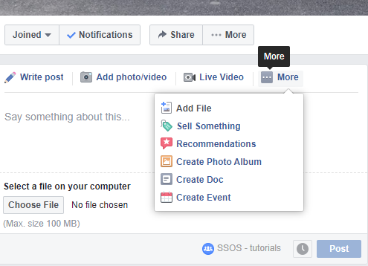

Use the Choose file to locate file on your laptop

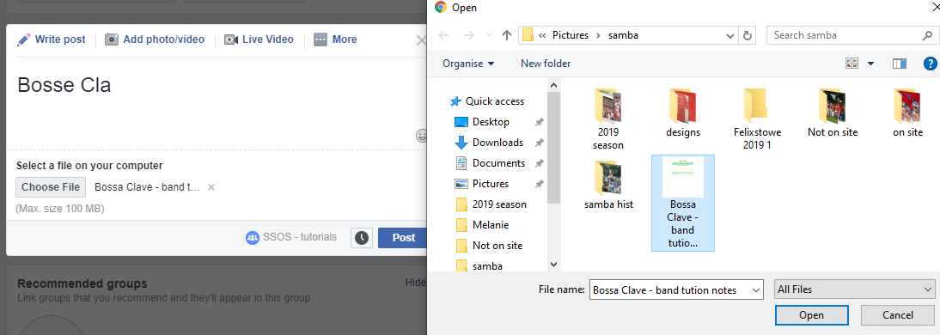

Choose the file you want to upload – and select ‘open’ which will upload it to the group.

Put some detail in the ‘Write Post’ area to describe what you are uploading for eg ‘Bosse Clave – Band Tuition Notes’.

And POST

Once uploaded – go to ‘topics’ and select the one relevant to the post

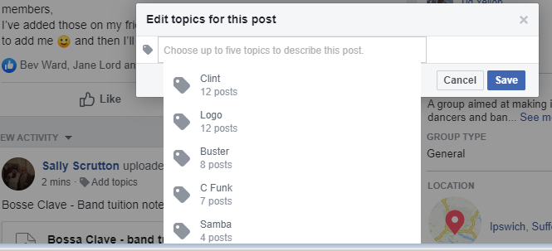

This should mean that anyone trying to find them can go to the name of the music title

SS 30/09