**Uploading photos & videos to SSOS – Tutorials**

Go to group on Facebook using the phone you took video on (or whatever you used)

Go to ‘Write something’ and click ‘photo’

 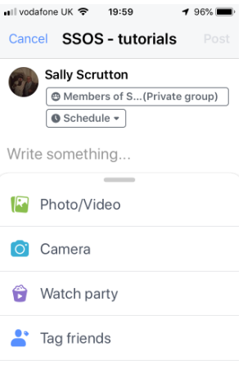

Find the picture\video that you wish to upload and press done – this will upload the post – when uploaded click on ‘Topics’

 

Chose the ‘Topic’ for the photo\video – and press ‘done’ – this should put the tag on the post

 

SS 30/09